**Preparing your Will**

**/**

**Thank you** for considering leaving a gift to Wycliffe in your Will; you might like to use this checklist to help you begin to prepare it. Don’t worry about the detail; make a start and fill in more as you go through the thought process. The checklist can also be downloaded from **wycliffe.org.uk/gifts-in-wills** in the ‘how to write a will section’. Once you have completed the below, you might like to email or post it to your solicitor before meeting with them.

A new Will automatically cancels earlier Wills. Your solicitor will prepare a draft Will for you to consider, advise you on practical and legal aspects, and give you tax advice if necessary on inheritance tax etc. When your Will is ready, you need to sign and date it in the presence of two witnesses, who will also sign it themselves. You can always revise your Will if you need to.

If you wish to claim a **free Will** through Wycliffe or need some further confidential advice, please get in touch with us as we would be more than happy to assist you.

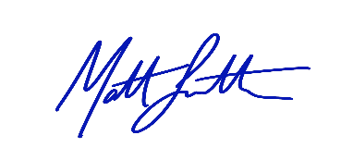Every blessing,



**Matt Smith**

Legacy Manager

Wycliffe Bible Translators

**Checklist - Please complete the following:**

1. **You and your family:**

Your full name:

Your email and phone:

Your date of birth and nationality:

Country where you live now:

Your full address and postcode:

Your marital status:

Spouse’s full name:

Spouse’s date of birth:

Children’s full names:

Children’s date of births:

If under 18 years, have you chosen and agreed guardians? YES / NO  
Guardian 1 name and address:

Guardian 2 name and address:

1. **Your property and assets:** (a rough guide is enough)

**House** (address and estimated value):

**Mortgage** (lender’s name, total loan amount):

**Second property** (address and estimated value):

**Mortgage** (lender’s name, total loan amount):

**Other properties:**

**Assets abroad** (address and estimated value):

**Savings plans and ISAs etc.** (bank / building society name):

**Life insurance** (insurer’s name):

Have you completed a nomination form with them? Yes / No

**Pension(s)** (provider’s name(s)):

Have you completed a nomination form with them? Yes / No

**Other main assets** (just a brief list: shares, vehicles, jewellery etc.):

1. **Your Will**

**Have you made a Will before?** If yes, where is it held? Do you have a copy?:

Is your spouse also making a Will now? Yes / No / n/a

**Executors:** have you chosen and agreed up to four people? It is normal to ask them first. They could be family members, close friends, or a solicitor. Yes / No

Executor 1 (name and address):

Executor 2 (name and address):

Other Executors (name(s) and address(es)):

**Your funeral instructions:** have you discussed this with your spouse / family? Yes / No

Please indicate your funeral preference:

Burial / Cremation / Body for research / for medical purposes

**Lasting Power of Attorney (LPA):**

LPAs allow others to care for you during your lifetime, if you are unable to.

*(note: for an old enduring Power of Attorney – different rules apply).*

There are two types of LPA: (1) for health and care; (2) for money and property.

Have you appointed attorneys? If so, please give their names and addresses:

Attorney 1 (name and address):

Attorney 2 (name and address):

1. **What are your main wishes?**

**Gifts in you Will you wish to make** (these can be a % share of the estate, an item, a fixed cash amount, etc.)

Please identify item / amount / share and to whom it is given:

**Share of estate:**

(Share between people and/or charities). State equal shares or % share for each:

Gift 1: % share:

Given to (full name person or charity name):

Gift 2: % share:

Given to (full name person or charity name):

Gift 3: % share:

Given to (full name person or charity name):

**Personal property items:**

Item 1: give to (full name):

Item 2: give to (full name):

**Money (fixed cash amount):**

Gift 1 amount: given to (full name of person or charity):

Gift 2 amount: give to (full name of person or charity):

Gift 3 amount: give to (full name of person or charity):

Gift 4 amount: give to (full name of person or charity):

Gift 5 amount: give to (full name of person or charity):

**5) Wycliffe’s details:**

**Whilst you may decide to give to a number of charities, if you wish to leave a gift to Wycliffe, the details and wording you need for your Will are as follows:**

**To leave a percentage of your estate (residuary legacy)**

*‘I leave to Wycliffe UK Ltd, CMS House, Watlington Road, Oxford OX4 6BZ, Charity Registration Number 251233, _____(percentage of residue to be completed)____ for its general charity purposes and I direct that the receipt of the Treasurer or other duly authorised officer shall be a sufficient discharge to my executors.’*

**To leave a specified amount (pecuniary legacy)**

*‘I leave to Wycliffe UK Ltd, CMS House, Watlington Road, Oxford OX4 6BZ, Charity Registration Number 251233, the sum of £_____ (specified amount in both figures and words)___ for its general charitable purposes and I direct that the receipt of the Treasurer or other duly authorised officer shall be a sufficient discharge to my executors.’*

**6) Information about Inheritance Tax (IHT)**

There is no IHT to pay if your Net Estate (total assets less liabilities) is less than £325,000 or you leave everything to your spouse, civil partner, or to church or charity. For those with an owned residence and children, stepchildren or adopted children, there is no IHT to pay if your Net Estate is up to £500,000 (as the residential nil rate band applies for an additional £175,000).If your Net Estate is more than £325,000 (the personal nil rate band), IHT is payable at 40% on the excess (the ‘Taxable Estate’). Please speak with a solicitor as there may be additional allowances claimable (e.g. widowers etc.).

**Tax Benefits for leaving gifts in your Will:** It is worth noting that if you leave 10% or more of your Net Estate to registered charities, the Taxable Estate is reduced by that gift, AND you only pay tax on the remainder at 36% not 40%. **This could mean a significant tax saving**

**Please note: In all cases when considering writing or amending your Will, we highly recommend that you contact a solicitor for advice regarding your wishes.**

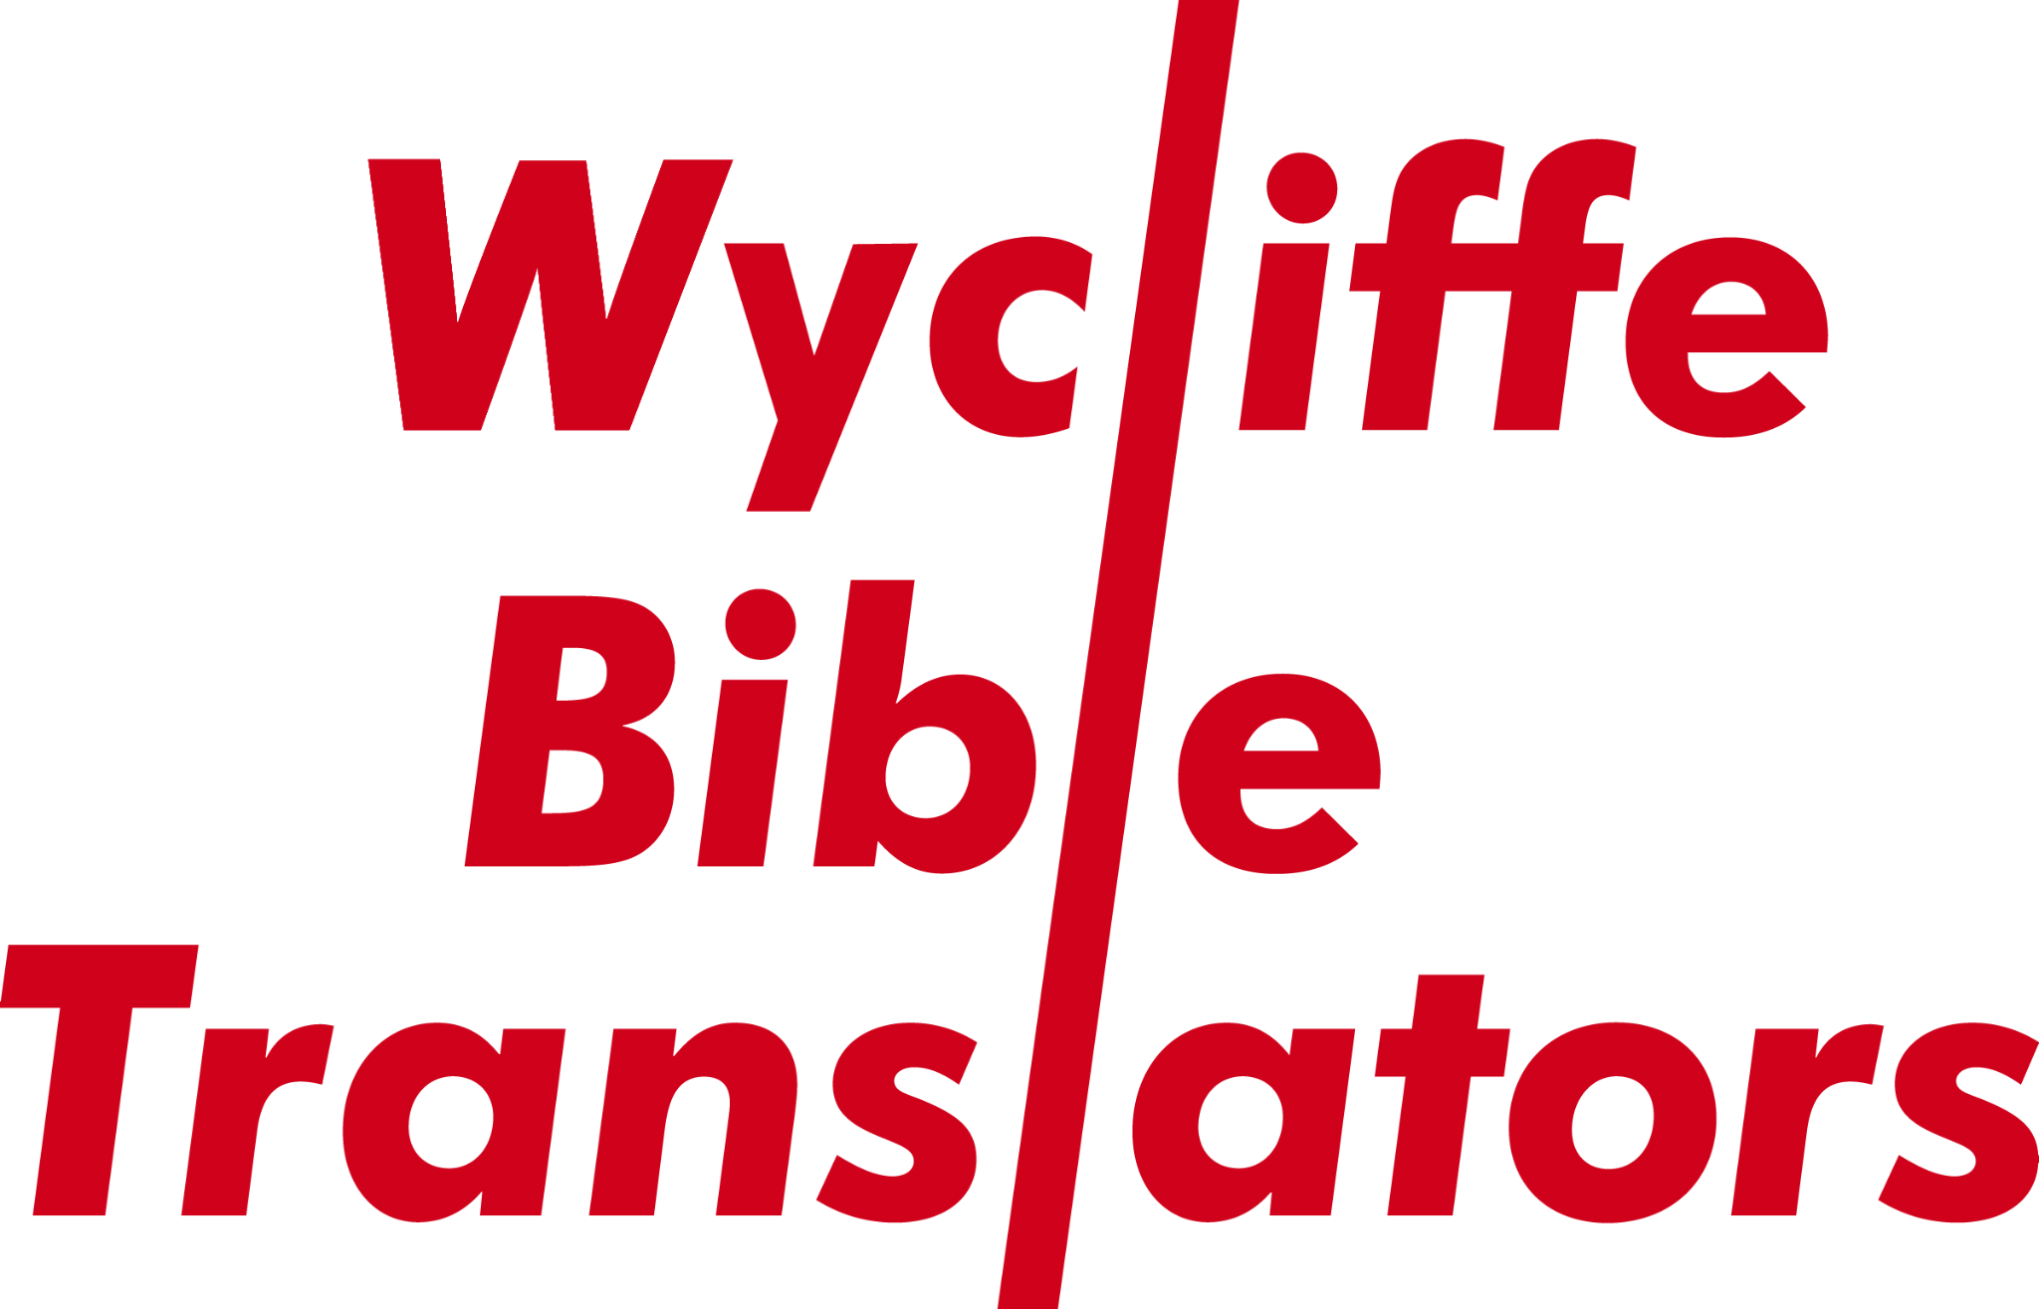

If you would like to know more about the work of Wycliffe and the impact of a gift left in a Will to support the ongoing work of Bible translation, please visit:

**Wycliffe.org.uk/gifts-in-wills**